Lab Objective

Learn how to Configure IE Settings

**Lab Procedures**

**1.** On RWDC01, using the Group Policy Management Editor for GPO5, navigate to and click User Configuration\Preferences\Control Panel Settings\Internet Settings.

**2.** Right-click the Internet Settings node, click New, and select Internet Explorer 10. The New Internet Explorer 10 Properties dialog box opens as shown in Figure 22-4.

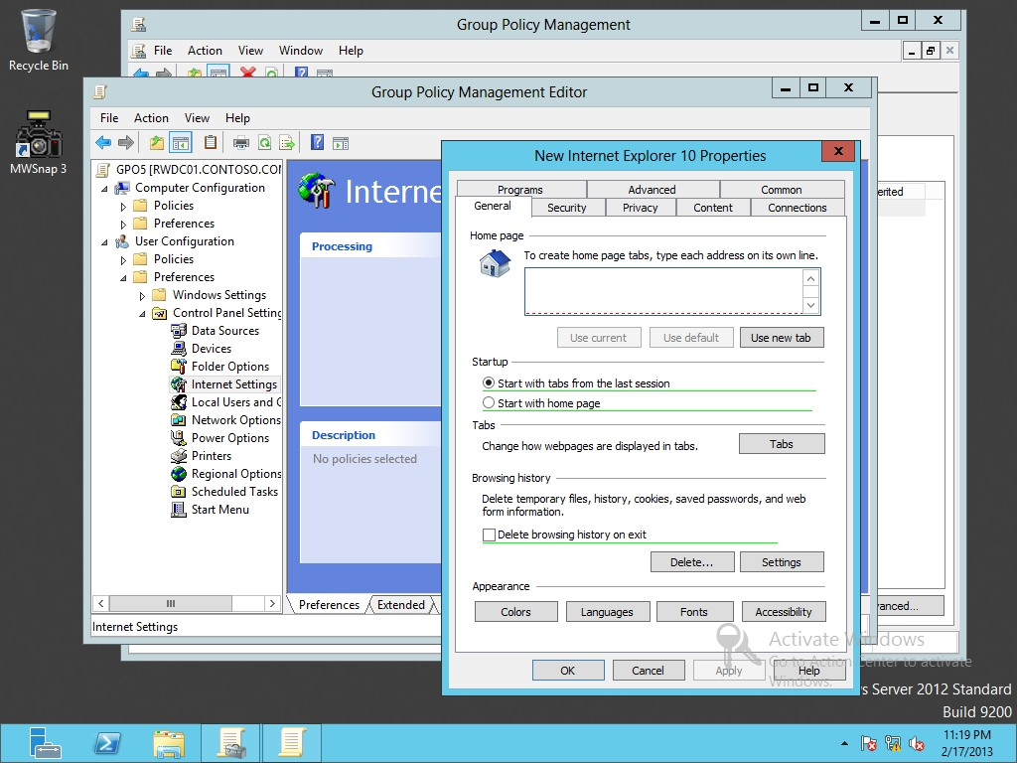

Figure 22-4

Configuring Internet Explorer 10 with preferences

**3.** Under the General tab, type **http://portal.contoso.com** in the Home page text box. Click Start with home page.

|  |  |
| --- | --- |
| Question 3 | What color is the home page set as? |

|  |  |
| --- | --- |
| Question 4 | What color is the Startup options set as? |

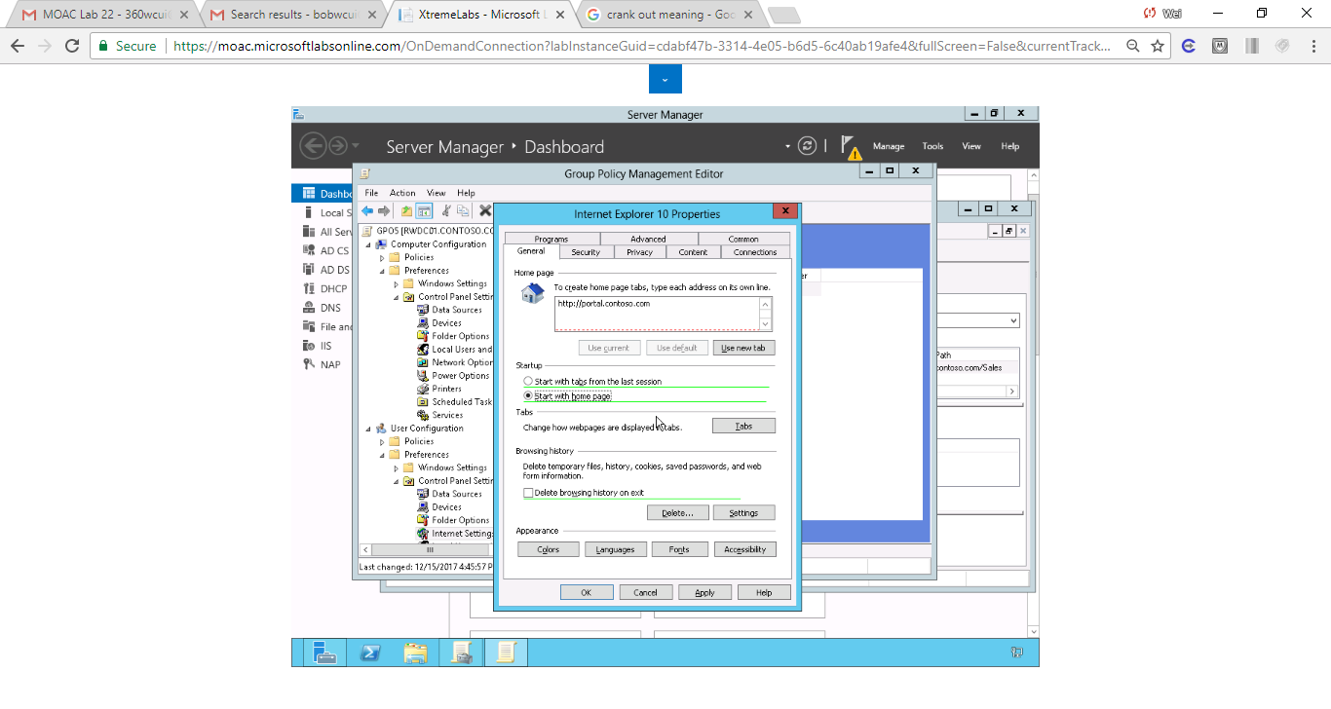

Figure Set up home page in Internet Explorer 10 Properties.

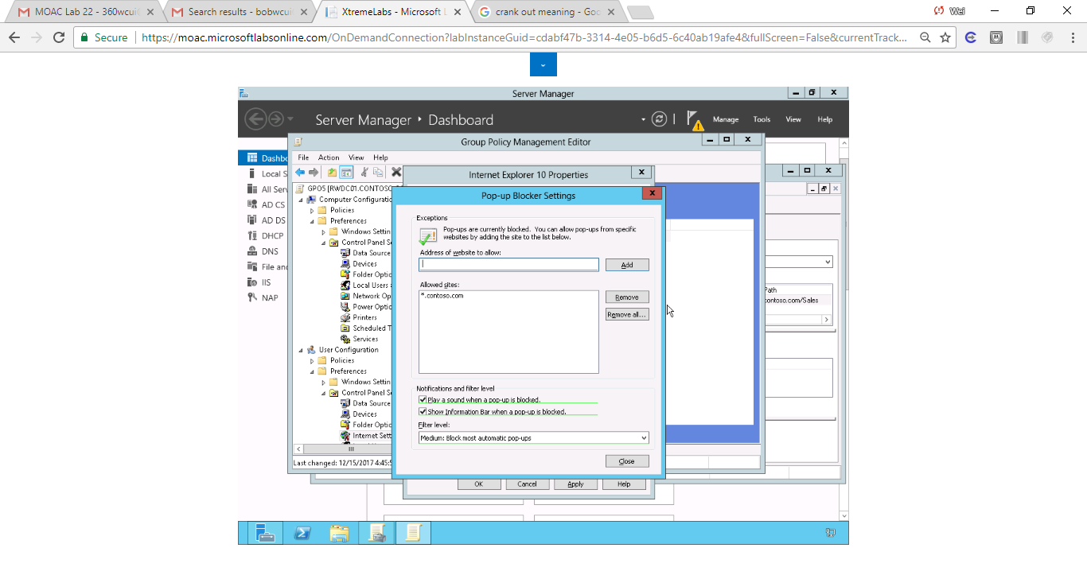



**4.** Click the Home page text box. Press the F5 key so that the box turns green.

|  |  |
| --- | --- |
| Question 5 | What key would you use to disable the current setting? |

**5.** Click the Privacy tab. Under the Pop-up Blocker section, click Settings.

**6.** When the Pop-up Blocker Settings dialog box opens, type **\*.contoso.com** in the Address of website to allow text box. Click Add. Click Close.

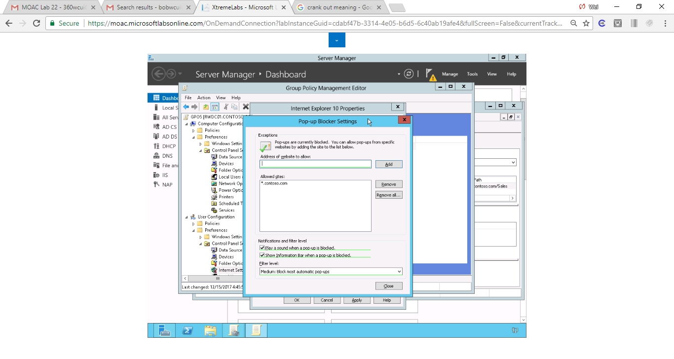

Figure **\*.contoso.com** in the Address of website is exempted in pop-up blocking settings

**7.** Click OK. The new preference item appears in the Internet Settings pane.

**8.** Right-click Internet Settings, click New, and click Internet Explorer 8 and 9.

**9.** Configure the setting similar to what you configured with the Internet Explorer 10 preference.

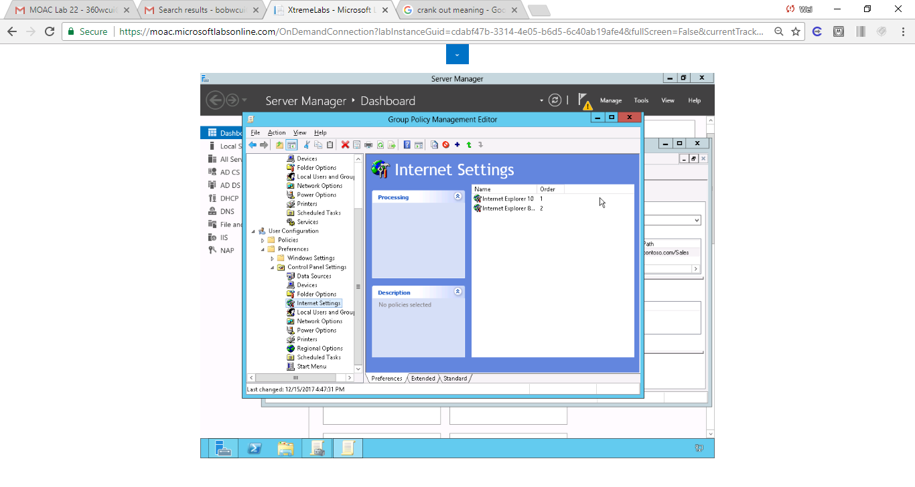

Figure Internet Explorer 10, 8 and 9 are successfully configured.

**10.** Take a screen shot of the Group Policy Management Editor window showing the Internet Settings by pressing Alt+Prt Scr and then paste it into your Lab22_worksheet file in the page provided by pressing Ctrl+V.

**11.** Leave Group Policy Management Editor open for the next exercise.

End of exercise

**Lab Summary**

In this exercise, I configured IE (versions 8 through 10) with a predefined home page and pop-up blocker exceptions. I learned to how enable home page settings by pressing F5. This lab is pretty straightforward as setting up IE on a home laptop is common and the process is same.